Dear Parents/Carers,

Over the next few weeks, I am aiming to produce a series of quick ‘Explainers’ to allow you to understand why we have the systems and structures we do. We have worked very hard with staff and Scholars (our students) so that they understand different elements of the school. We hope that by doing this, you will understand how the school operates and, most importantly, why! We are going to start with one of the most important aspects of the school:

1. Homework

At Kirk Hallam, ‘Homework’ will be created to assist learning which occurs in the classroom, rather than being a pointless ‘add-on’ it will act as a means for teachers to understand what students have learned and what they need to re-teach. As a school we have worked incredibly hard with staff to train them in the production of homework so that it is never pointless but instead, aids learning.

For a brief example of this theory, the diagram below will help (we will be using this quite often in these guides!):

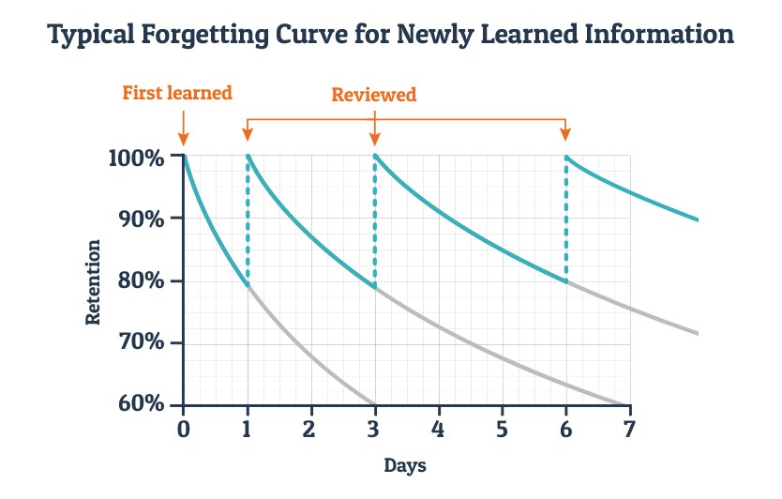

As you can see, when we teach things, if we never go back to them, then our children will tend to forget them very quickly. If instead, we use tools like homework, quizzes in lessons and activities such as recall or revision techniques, children are more likely to remember them. The more they remember, the better they will learn new information! Linked to this, the more variety we present this information in, the better they will be able to remember.

When is it given and how will you know?

Like everything, we try to keep things as simple as possible at Kirk Hallam so that there is no room for confusion for our Scholars or Teachers. We have a very simple homework timetable, we will take homework in in the morning and then provide an opportunity for Scholars to catch up on any homework they have not handed in at the end of the day with that teacher. It is critical that we have homework handed in so that our Teachers can plan their lessons as effectively as possible.

Homework Schedule for 7-9
Year | Mon | Tuesday | Wednesday | Thursday | Friday
7 | English | Maths | Science | History | Geography
8 | English | Maths | Science | History | Geography
9 | English | Maths | Science | History | Geography

Homework Schedule for 10-11
Year | Mon | Tuesday | Wednesday | Thursday | Friday
10 | English | Maths | Science | Opt A/B/C on Rota
11 | English | Maths | Science | Opt A/B/C on Rota

Homework will be collected in on these mornings and Scholars given an entire week to get it done. If any are struggling with any element of their homework or they misplace their homework then they can speak to their teachers and we will help them. Really this needs to be done BEFORE the hand-in date. We also understand that for our younger Scholars, we need to help them get used to the system and so years 7 and 8 both have a study period built into their week where they can do their homework.

You will be able to see the homework easily as it will always be on light blue paper and we will feedback to Scholars on their homework through a 1-4 mark (1 being the best). You will see an average of these scores every 9 weeks when you receive a written report.

What if homework is not completed?

As we stated right at the top, we need homework to be completed so that teachers can be really clear about how they can plan for their classes. If homework is not handed in during the specific session then Scholars will complete it that night after school. We will never keep Scholars longer than 30 minutes but want to be in a position where this is never used as we get 100% of homework handed in. We will send a text home as close to mid-day as possible should this apply to your child. Obviously if a Scholar has been absent for a week and hand in day is their 1st day back, this won’t apply to them.

Rewards

Handing in homework, although an expectation, will come with a reward which will automatically be applied to Kickboard. When homework is marked and is deemed to be excellent, further rewards will be added in the form of PRIDE Coins. I have added a list of some of the different types of homework you should expect to see to the next page.

Yours sincerely
Damian Belshaw
Head of School

Homework Planning Ideas
Homework type | Example activities | When to use
Recall/revision | - Work from KO-blanked out examples.  - Example/non-example.  - Vocabulary task.  - Repeated task from the lesson.  - Summary/paraphrasing.  - MQC. | - At the end of a sequence of learning.  - End of an AC.
Pre-learning | - Pre-reading with set questions.  - Text dependent questions.  - Vocabulary task.  - Modelled activity. | - Before a harder lesson.  - Before an AC test.  - Before an interim assessment activity.
Key Reading | - New texts with Text Dependent Questions.  - Linked books/reading/articles.  - Similar sources. | - Before or after a specific activity.  - Before an AC assessment.
Extending learning | - Exam based questions.  - Extended essays.  - Comparison activities.  - Edit and Revision. | - Any time.  - Should be the majority of homework types in any AC.

