Biology unit 1 homework - Mark schemes
Q1.
(a) 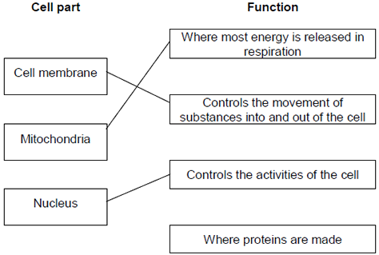
extra lines cancel
3
(b) Cell wall
in either order
1
Chloroplast
allow (permanent) vacuole
1
[5]
Q2.
(a) (i) A − (cell) wall
1
B − cytoplasm
1
C − plasmid
1
(ii) bacterium cell has cell wall / no nucleus / no mitochondria / plasmids present
accept its DNA / genetic material is not enclosed / it has no nuclear membrane
it = bacterium cell
accept converse for animal cell
ignore flagella
1
(iii) any one from:
• chloroplast
ignore chlorophyll
• (permanent) vacuole
1
Q3.
(a) chromosomes
1
(b) diagram showing four separate chromosomes two long and two short
(as in diagram 1)
allow each chromosome shown as two joined chromatids
do not allow if chromosomes touching each other
1
Q4.
(a) any two adaptations with linked descriptions from:
• many alveoli to provide a large surface area
• good blood supply to maintain steep diffusion / concentration gradient
• thin walls so gases do not have far to diffuse / travel
• well ventilated to maintain steep diffusion / concentration gradient
1 mark for adaptation and 1 mark for linked description
allow to collect oxygen or to bring carbon dioxide to lungs
4

Q5.
(a) diffusion
1
active transport
1
1
Q6.
(a) a tissue
1

